**Network Visualization using Networkx**

**Nimesh Sinha**

Q1.

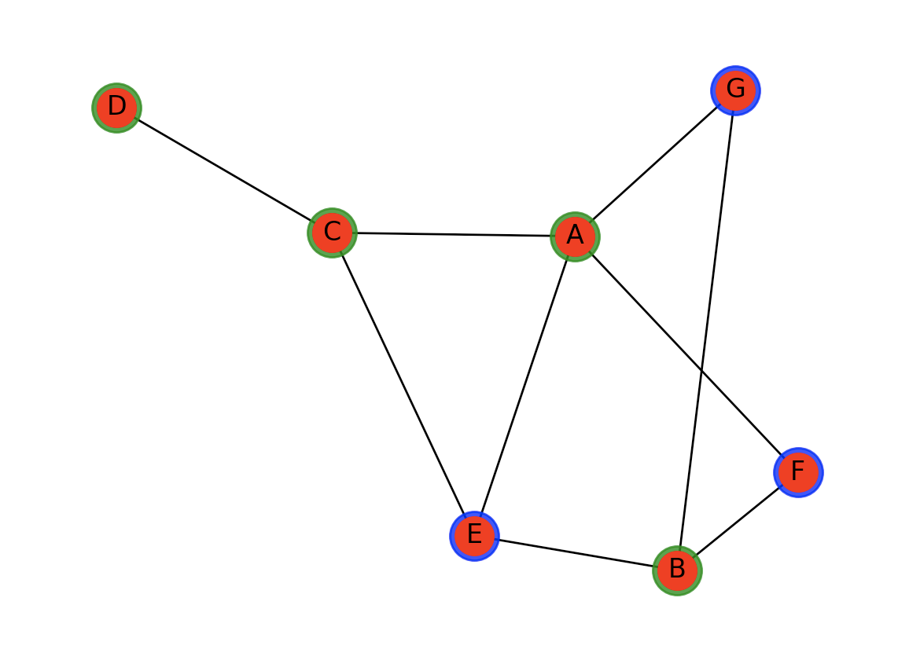

This is an undirected unweighted graph. The border color of nodes denotes different type of nodes.

Q2.

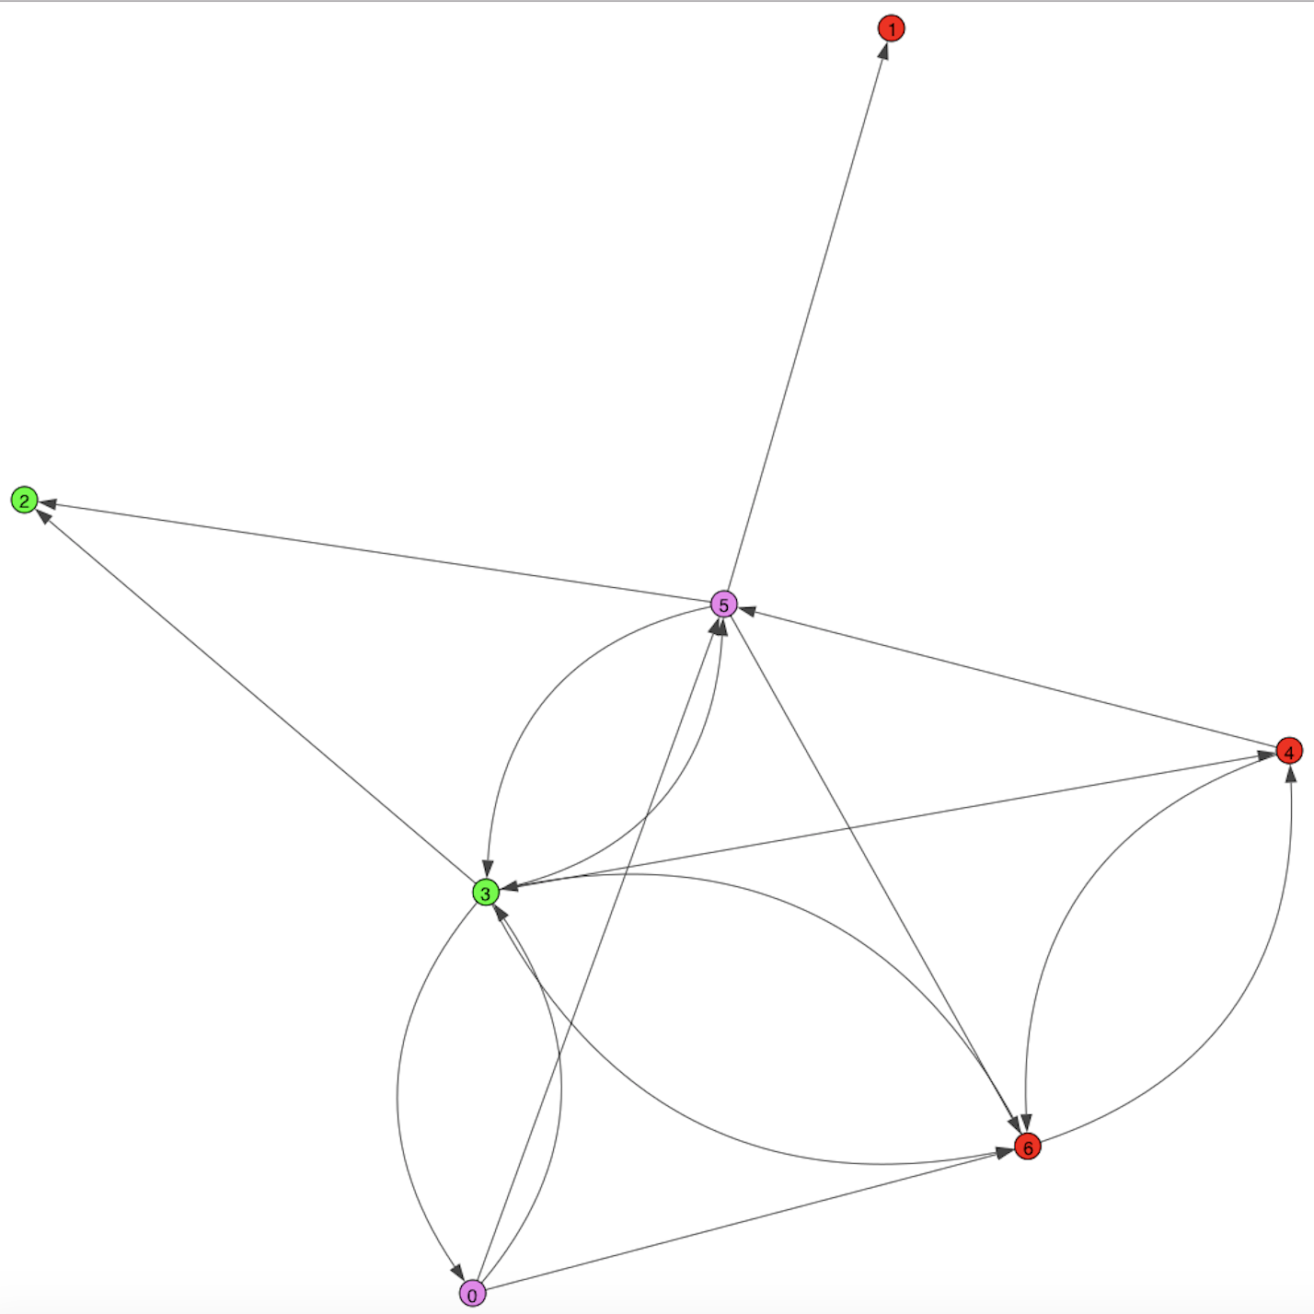

This is a directed unweighted graph. Different color of nodes represent different types of nodes.